Missouri Market
Development Program

Application for Financial Assistance
for the acquisition of equipment
necessary to manufacture products
from recycled materials
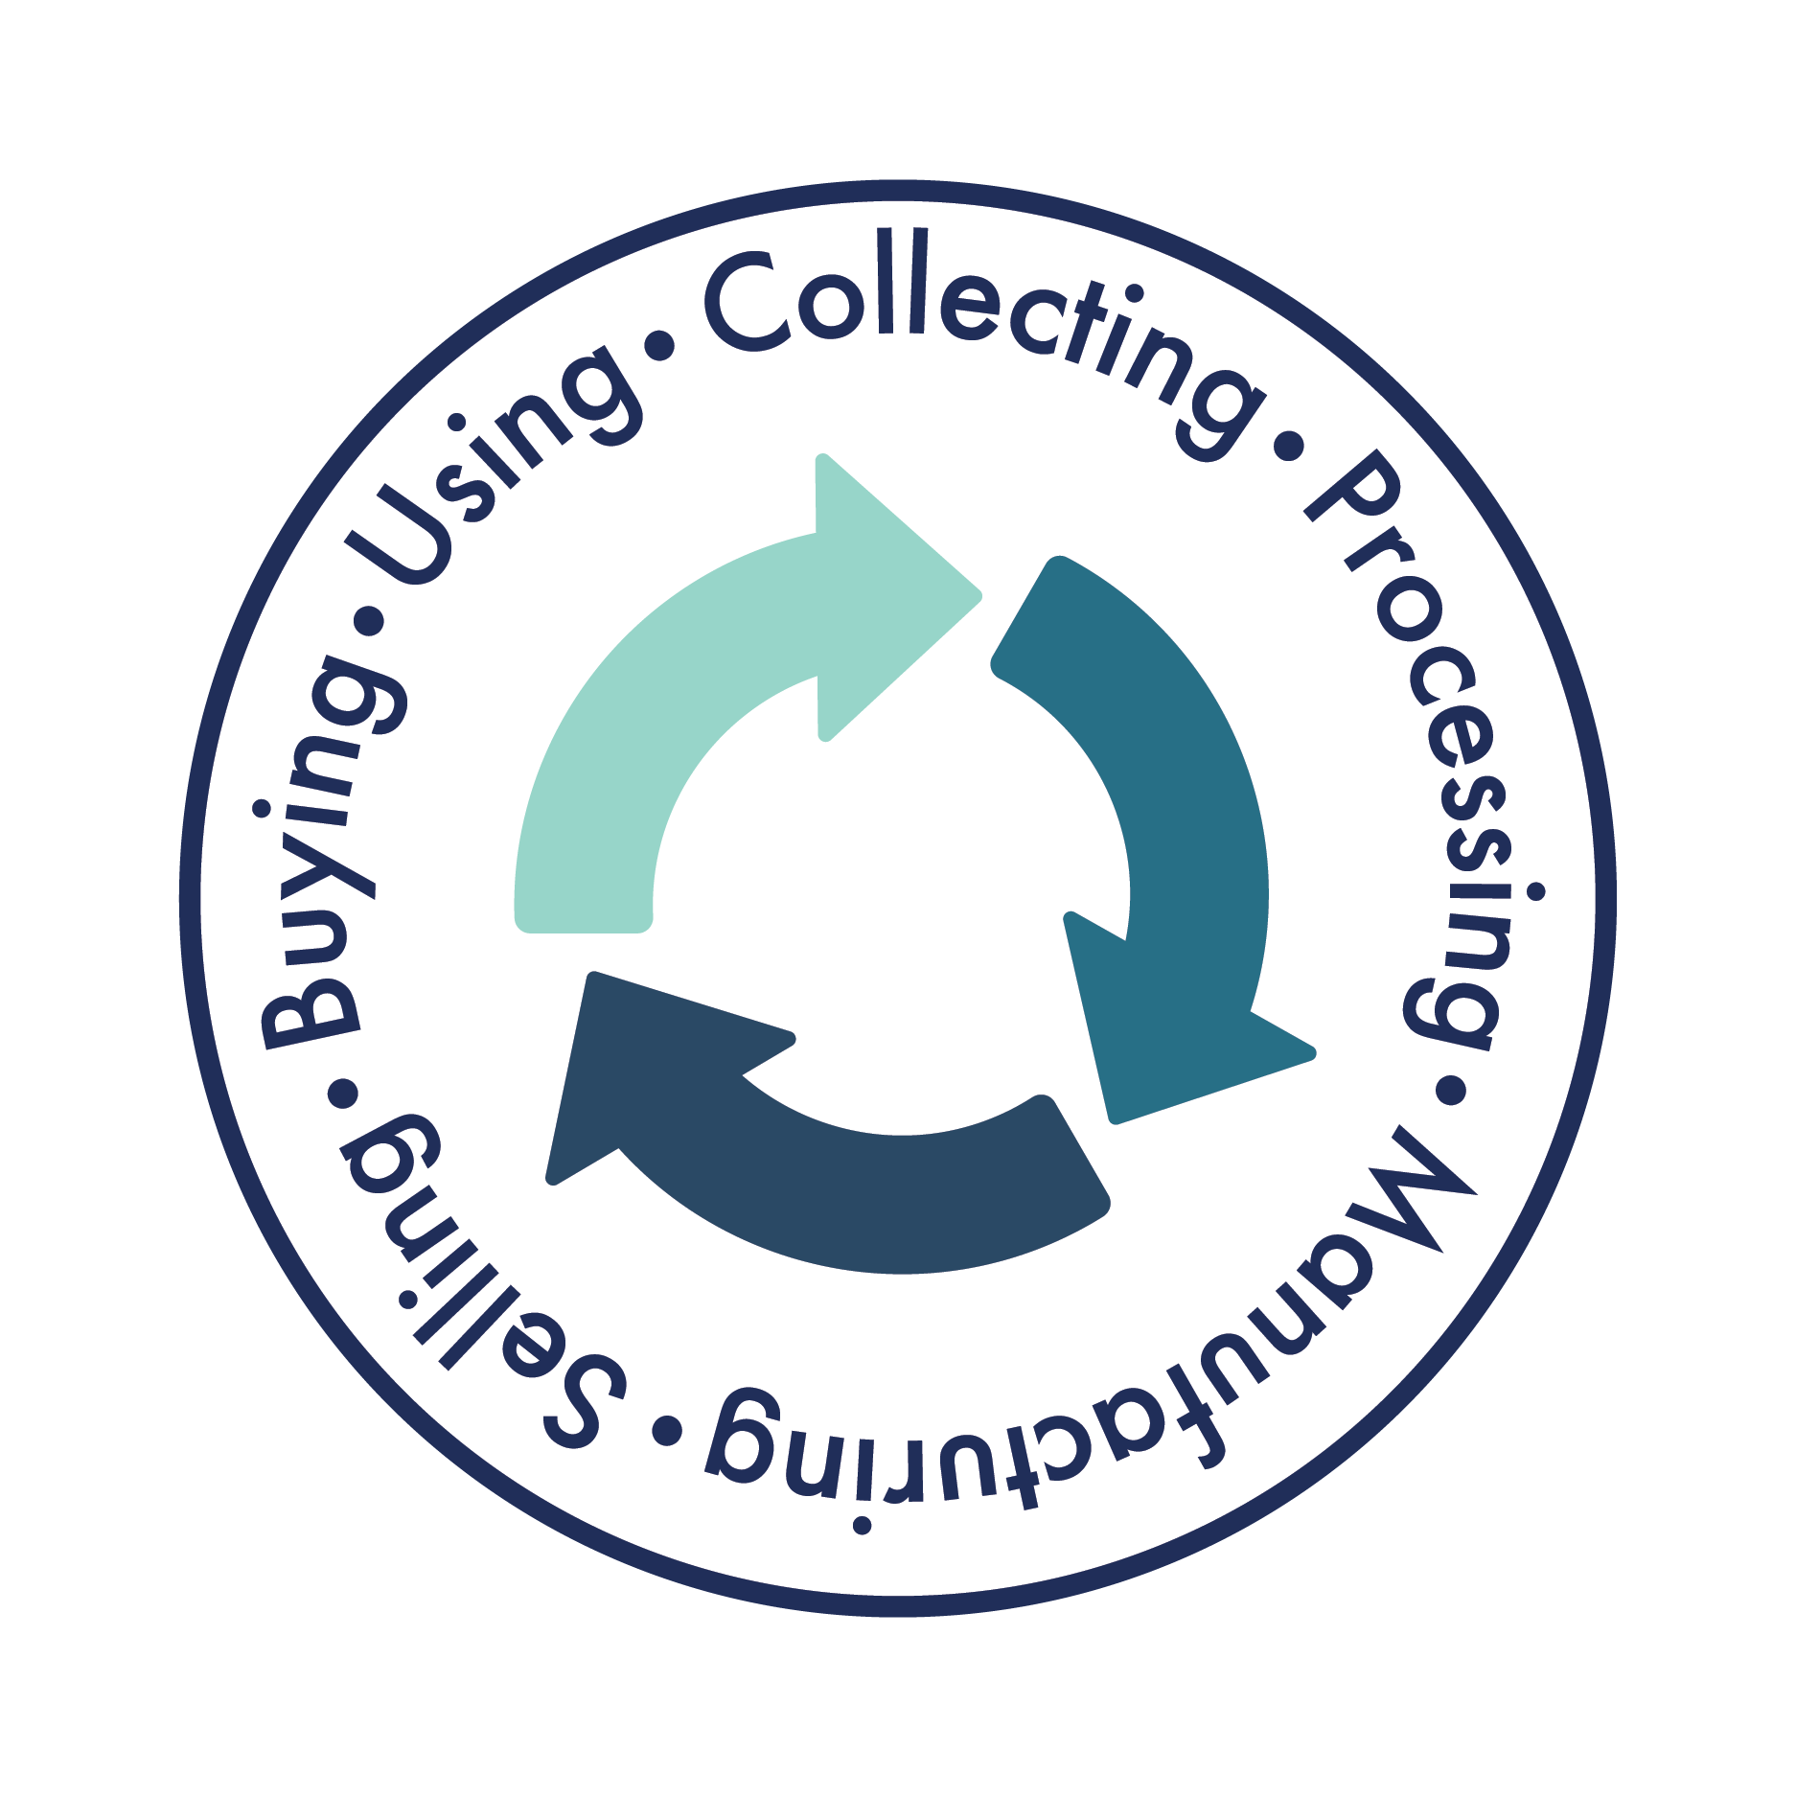

Offered by the Missouri
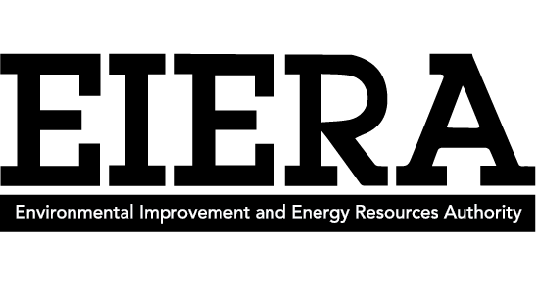
Environmental Improvement and Energy Resources Authority
in cooperation with
Department of Natural Resources
and Department of Economic Development

TABLE OF CONTENTS
GENERAL INFORMATION

Eligibility Criteria…………………………………………………………………………………. 3
Program Administration……………………………………………………………………….4
Eligibility…………………………………………………………………………………………….… 4
Financial Assistance Amount…………………………………………………………..…… 5
Selection Process…………………………………………………………………………………. 5
Evaluation Criteria……………………………………………………………………………..… 5
Submittal Requirements………………………………………………………………………. 6
Acceptance or Rejection of Application……………………………………………..… 6
Confidentiality of Submitted Materials………………………………………………… 6
Financial Assistance Agreement……………………………………………………….….. 6
Where to Send Your Application………………………………………………………….. 7

APPLICATION

I. Financial Assistance Application Table of Contents……………………….. 8
II. Pre-Application Checklist…………………………………………………………….… 9
III. Project and Applicant Profile…………………………………………………………. 10
IV. Project Summary………………………………………………………………………..... 13
V. Recovered Material(s) Use……………………………………………………………. 17
VI. Marketing Strategy……………………………………………………………………..… 19
VII. Operational Financial Information………………………………………………...22
VIII. Applicant Disclosure………………………………………………………………………29
IX. Management Certification - Credit Report Authorization………………30
X. Equipment Bids……………………………………………………………………………..31

Attachment A – Cooperation with Solid Waste Management District….. 32

Attachment B – Financial Statement for general partnership, limited
Partnership, sole proprietorship, not for profit organization.………………33

Attachment C – Financial Statement……………………………………………………..34

Appendix A: Solid Waste Management District Planners………………………35

FOR FURTHER INFORMATION
If you have any questions, or are unsure whether your project would be eligible for consideration, please feel free to contact:

Missouri Market Development Program
Phone: (573) 526-5555
E-mail: angie.powell@eiera.mo.gov
kristin.allantipton@eiera.mo.gov

ELIGIBILITY CRITERIA – AWARD AMOUNT
Financial Assistance applicants to the Missouri Market Development Program may now seek eligibility to request up to $250,000 towards the purchase of specific equipment needed to manufacture a product from recovered materials or to process materials for use as manufacturing feedstock. Applications will now be assigned points in the categories of job creation, annual diversion and the contribution provided by the applicant. Increasing amounts of assistance are available as points scored by an application increase.
Minimum Points Required Per Award Amount

Up to $50,000 35
Up to $75,000 70
Up to $100,000 105
Up to $250,000 140

Eligible Applications Must Score Points in EACH of the Below Categories to be considered

Jobs Created Points
0 to 2 5
3 to 5 10
6 to 10 15
11+ 20

Tons Diverted Annually Points
20 – 499 5
500 – 999 10
1,000 – 10,000 15
10,000+ 20

Applicant Match Points
25% of requested award 25
50% of requested award 50
75% of requested award 75
100% of requested award 100

If the application addresses an MMDP Target, 25 points will be added to the total. Current targets include:
1) Construction and Demolition Waste,
2) Food Waste and Organics,
3) Plastics,
4) Tires, or
4) Location is a minimally funded Missouri Solid Waste Management District.

Minimally funded districts currently include the following:
- Region A – Northwest Mo SWMD;
- Region B – North Mo SWMD;
- Region C – Northeast Mo SWMD;
- Region J – Quad Lakes SWMD;
- Region N – Southwest Missouri SWMD;
- Region Q – Ozark Foothills SWMD; and
- Region T – Lake of the Ozarks SWMD.
- From time to time, other districts due to closing of permitted facilities may become minimally funded and included in this listing.

All other eligibility requirements for applicants and projects outlined in this application remain effective.

PROGRAM OBJECTIVE
The Missouri Market Development Program was created to promote recycling throughout Missouri by focusing economic development efforts on businesses and projects that use materials recovered from solid waste. Successful expansion of markets for recovered materials supports increased recycling activities, helping the state to reach its solid waste reduction goal.

As Missouri's goal of reducing solid waste through recycling and waste reduction is achieved, new recycling industries will be needed.

This new recycling infrastructure creates jobs and opportunities by adding value to recovered materials. Not only is the solid waste disposal problem reduced by using the commodity of recovered materials in the manufacturing of new products, the economy is expanded.

The financial assistance offered by the Missouri Market Development Program is targeted toward developing and expanding manufacturing capacity in Missouri to utilize recovered materials. Manufacturing, for the purpose of the Program, is any type of activity that utilizes recovered materials as feedstock to produce a marketable product.

PROGRAM ADMINISTRATION
The Environmental Improvement and Energy Resources Authority (EIERA) in cooperation with the Department of Natural Resources (DNR) and Department of Economic Development (DED) administer the Missouri Market Development Program.

Monies for the Program come from the Solid Waste Management Fund created pursuant to RSMo Section 260.330. The source of the funds is a per ton fee levied at sanitary landfills, a per ton fee for demolition landfills and a per ton fee on solid waste transported out of state through a transfer station for disposal. Funding for the Missouri Market Development Program is subject to the legislative appropriation process.

ELIGIBILITY REQUIREMENTS FOR APPLICANTS
An individual, private business, non-profit organization or public institution currently operating in Missouri or who will be operating in the state as a result of the project is eligible.

All projects must be located in Missouri and be based on a technology that has been demonstrated beyond the research stage. Further, they must be technically feasible for full-scale operation and comply with all applicable environmental, safety, and legal requirements.

ELIGIBILITY REQUIREMENTS FOR PROJECTS
Eligible projects include those resulting in;
- the manufacture of products from recovered materials and/or
- the final processing of recovered materials into feedstock.

Ineligible projects include those resulting in:
- research and development projects

Previous Grantees: An applicant that has previously received financial assistance from the Missouri Market Development Program may apply if the previously approved project is complete and all terms of the agreement are met. Repeat applications must demonstrate that a new product will be developed, different recovered materials will be used or a significant increase in diversion will be realized. A combination of these outcomes will strengthen the application.

Projects utilizing the following materials will not be considered:
- recovered metals;
- white goods;
- materials and by-products generated from, and reused within, the original process;
- tires, unless for a product other than crumb rubber;
- materials disposed of at a hazardous waste landfill or materials considered to be hazardous such as lead, acids and solvents.

For more information about hazardous materials, please contact:
Missouri Department of Natural Resources’
Hazardous Waste Program
Post Office Box 176
Jefferson City, Missouri 65102
(573) 751-3176

USE OF FINANCIAL ASSISTANCE FUNDS
- Eligible expenses include only the purchase of manufacturing equipment and machinery (or the conversion of existing equipment and machinery) to manufacture products that contain recovered materials (other than internal waste or mill-broke). Equipment purchased for the final processing of recovered materials to be used by others in the manufacture of recycled-content products is also eligible. Equipment purchased with Market Development funds should "add value" to the recovered material being used.

- Equipment purchases must be made after the effective date of a signed agreement to be eligible for funding up to the approved amount.

FINANCIAL ASSISTANCE AMOUNT
Applications are accepted at any time, however, applications received by the Program, after the funds available for the fiscal year have been committed to successful applicants, will be returned.

Upon financial assistance approval, the Market Development Program may fund up to 75 percent of specific equipment costs with a maximum funding level of $250,000. Eligibility for specific award amounts will be determined by the eligibility criteria described on page 3 of this application. No portion of the balance of the equipment cost can include Solid Waste Fund monies (DNR or Solid Waste Management District grants). The amount of funding offered will be determined in the evaluation process of the Market Development Steering Committee.

SELECTION PROCESS
All applications are first reviewed for completeness. Incomplete applications will be returned with a letter highlighting deficiencies to be corrected. Deficient or incomplete applications will delay consideration.

The Market Development Steering Committee, comprised of representatives from EIERA, DNR and DED, will evaluate all completed applications based on the Program’s evaluation criteria. Projects that meet or exceed the criteria for funding will be presented to the EIERA Board for review and final approval.

Funding for approved projects will be provided as a reimbursement of costs incurred for the purchase of the equipment. The EIERA Board will negotiate the method of payment, along with other contract terms, following any approval of financial assistance.
EVALUATION CRITERIA
The Program is particularly interested in projects that expand Missouri’s recycling business base while building markets for the materials collected through Missouri’s local recycling programs.

Factors which will be considered in determining whether to fund a project include: type and amount of recovered material used, jobs created, strategy for market development, operational capacity, technical feasibility, and financial feasibility.

A credit report will be requested to aid in the evaluation of an application for financial assistance. Typically, the report will be obtained on the business applying for financial assistance. However, if the business is new and does not have a credit history, a credit report will be obtained on the individual owner(s). Strict confidentially will be maintained. If your business is new and does not have a credit history, please complete Attachment C.

SUBMITTAL REQUIREMENTS
Applications may be submitted at any time during the year. Generally, a minimum of twelve weeks is needed for evaluation, recommendation and final decision. After a final approval of funding, terms of an agreement will be developed and an agreement must be executed.

Please submit only the original application (please leave the original in loose-leaf form), to the Market Development Program. The application must be marked with successive page numbers. Extra material provided or attached to the financial assistance application must be numbered sequentially. Non-compliance with this section may result in the inability to process the application.

ACCEPTANCE OR REJECTION OF APPLICATION
The Market Development Steering Committee reserves the right to accept, reject, or request changes in any application for financial assistance. The Market Development Steering Committee may approve any number of applications, as deemed in the best public interest of the state of Missouri. The Market Development Steering Committee is not obligated to provide a debriefing for unsuccessful applicants. The Market Development Program is not liable for any costs incurred by any parties seeking funding.

CONFIDENTIALITY OF SUBMITTED MATERIALS
To the extent feasible and permissible by law, the Market Development Program will honor an applicant’s request to keep financial and proprietary information submitted in an application confidential. Such information will be treated as confidential only if each page of the information to be kept confidential is specifically marked or identified as confidential by the applicant.

If the application results in an award of financial assistance, the honoring of confidentiality of identified data shall not limit EIERA’s right to disclose the results of the project to the public.

FINANCIAL ASSISTANCE AGREEMENT
Projects receiving financial assistance from the EIERA Market Development Program will be required to enter into an agreement with the EIERA. The Agreement will be secured through a security interest on the equipment purchased through Market Development funds, and a Demand Note. Ten percent of the financial assistance amount may be held as retainage until the end of the project. These steps are taken to ensure that the monies provided through the Solid Waste Management Fund, and ultimately by the citizens of Missouri, are used appropriately.

The approved application for financial assistance will be incorporated into the Agreement as the Scope of Work. Upon successful completion of the Project within the agreed to timetable, all necessary requirements in the Agreement, including the security interest in the equipment and demand note will be released.

Following is a brief discussion of some of the requirements of the Financial Assistance Agreement.
TERM
The term for all projects, unless otherwise noted in the Agreement, shall be two years. The effective date of the agreement will depend on the specific project, and the date of approval.

PROJECT REPORTS
Quarterly reports are required, detailing the project’s progress and including information on tons diverted for that quarter, problems encountered, status of scope of work schedule and production. Reports are due by January 10, April 10, July 10 and October 10. Quarterly reports are to be submitted to the Market Development Program with a copy to be provided to the Solid Waste Management District in which the project is located. In addition, projects are asked to provide an informal presentation to the Steering Committee on or near the first anniversary of the agreement.

A final report will be requested at the end of the project. This is a comprehensive report over the term of the agreement detailing total tons diverted, project successes, problems encountered and any information for improvement of the Market Development Program.

COMPENSATION
If the project is carried out in a timely manner, all quarterly reports are submitted as required and a final comprehensive report provided, the funding retained until project completion will be provided as soon after the termination date of the Agreement as possible. If any terms of the Agreement are violated, the retained monies will not be provided. Also, in the case of Agreement violations, the EIERA may seek return of compensation provided under the Agreement. The EIERA will provide written documentation of Agreement violations.

ACCOUNTING SYSTEM
Projects receiving financial assistance from the Market Development Program shall maintain an accounting system according to generally accepted accounting principles that accurately reflects all financial transactions, incorporates appropriate controls and safeguards, and provides clear references to the Project proposal. Accounting records must be supported by such source documentation as canceled checks, paid bills, payrolls, time records, contracts, and agreement award documents.

RETENTION AND CUSTODIAL REQUIREMENTS FOR RECORDS
Projects receiving financial assistance shall retain all records and supporting documents directly related to the project for a period of three years from the date of submission of the final report. Upon request, they must be made available to the Market Development Program.

PERMITS
It is the responsibility of the applicant to be in compliance with all applicable environmental laws and regulations and to obtain all required permits and licenses for the operation of the project. Proof of proper permits may be requested before funding is provided.

TAXES
The applicant is responsible for determination and payment of any taxes relating to the Agreement. The applicant will receive a 1099 from EIERA in January, if project is awarded.

WHERE TO SEND YOUR APPLICATION
Only the original application is required. Please leave your original application unbound. Original application must contain ORIGINAL signatures. Please use blue ink for signatures on original application. Faxed applications are not accepted. Failure to label attachments as described throughout the application could result in your application not being processed.

You may mail or deliver your application to:

Missouri Market Development Program/EIERA
Post Office Box 744
425 Madison Street, 2nd Floor
Jefferson City, Missouri 65102-0744

I. FINANCIAL ASSISTANCE APPLICATION TABLE OF CONTENTS
THIS MUST BE FILLED OUT COMPLETELY
THIS BECOMES PART OF YOUR APPLICATION

Applications should be submitted in the following order

Document(s) Page Number
I. Financial Assistance Application Table of Contents
II. Pre-Application Checklist
III. Project and Applicant Profile
IV. Project Summary
A. Project Goals
B. Project Description
C. Project Need
D. Project Workplan and Time Table
E. Permits
F. Cooperation with Solid Waste District
V. Recovered Materials Used
A. Type of Material
B. Annual Consumption
C. Avoided Cost of Disposal
D. Sources
E. Collection and Delivery
F. Payment for Recovered Material
VI. Strategy for Market Development
A. Recycled Products
B. Market Description
C. Marketing Strategy
D. Pricing
E. End Markets
F. Competition
VII. Operational and Financial Information
A. Management Profile
B. Company Summary
C. Projections
D. Cash Flow
E. Financial Statements
F. Employment
G. Ownership & Officers (if applicable)
H. Principal Stockholders (if applicable)
I. Support Services (if applicable)
J. Total Company Debt (if applicable)
K. Attachment B – Financial Statement (if applicable)
L. Attachment C – Financial Statement (if applicable)
VIII. Applicant Disclosure
IX. Management Certification - Credit Report Authorization
X. Equipment Quotes

II. PRE-APPLICATION CHECKLIST

Business Name:

Before submitting an application for financial assistance, you MUST complete this form. Only if the applicant can answer YES to questions 1 through 7 on this form should the application be prepared for submission.

YES NO

1. The project will be performed in the state of Missouri.

- The project can be demonstrated to be technically feasible.

3. The project will result in (a) the final processing or conversion
of recovered (recycled) materials into industrial feedstock; and/or
(b) the manufacture of products from those feedstock’s.

- Funding request is for the purchase of equipment or machinery
that will be used for the manufacturing of products that contain
recovered materials or final processing of recovered materials.

5. The applicant will contribute a portion of the total project cost.

- The project will secure sources of recovered materials
in Missouri and will secure markets for the end-products produced
as a result of the project.

7. The recovered material used in this project,
(a) would have gone to a sanitary or C&D landfill in Missouri; or
(b) has been banned from disposal in Missouri landfills.

8. Funding amounted requested complies with eligibility criteria outlined
on page 3 of this application.

- Has this organization received financial assistance from the
Missouri Market Development Program previously?

If "yes," please complete the following:

9A. The project will develop a new product.

9B. The project will use different recovered materials.

9C. The project will realize a significant increase in diversion.

III. PROJECT AND APPLICANT PROFILE
Please fill out the application in its entirety, if sections are left blank, your application may NOT be processed.
If parts are not applicable to your business, please state reason.

Business Information
- Legal Name of Business, Person or Entity Requesting Assistance:
- Physical Address:
City: | State: |  |  |  | Zip:
Phone: ( ) |  |  |  | Fax: ( )
Company Website:
- Name and Title of Authorized Official:
Phone: ( ) | Fax: ( ) |  |  |  | Mobile: ( )
E-mail Address:
Project Information
4. Amount Requested: |  | Total Equipment Cost: |  |  |  | Total Project Cost:
5. Project Description:
6. This Project is (check one):
A completely new venture for an existing business An expansion of a current activity
A new business Other – please describe:
7. This project will divert tons from the waste stream annually.
8. Approving this project will create (check all that apply):
Full Time Employees (FTE) Number of positions created:
Part Time Employees (PTE) Number of positions created:
9. This project deals with (check all that apply):
Yard Waste Sawdust Lumber Plastics
Glass Wood Other – please describe:

Type of Applicant

Type of applicant
Corporation General Partnership Limited Partnership
Limited Liability Company Sole Proprietorship S-Corporation
501 (c3) not-for-profit Individual Public Institution
Your application will NOT be processed without this following information
Corp. ID No: Fed. Tax ID No: Social Security No:

Contact Personnel – If Different from Authorized Personnel Listed Above
- Project Manager or Main Contact Person:
Mailing Address:
City: | State: |  |  |  | Zip:
Phone: ( ) | Fax: ( ) |  |  |  | Mobile: ( )
E-mail Address:

Site Location

12. Physical address (of project site):
City: | State: |  |  |  | Zip:

Status of Property:
Owned Leased Under Consideration Other – Please Describe:

County in which project will be located:

Please list Solid Waste District Region (i.e. A, B, C…) your project will be located in:

A list of regions can be found on page 35 of this application.

Missouri Legislative representatives in the area in which the project is located: DO NOT INCLUDE U.S. SENATORS
Missouri State Senator: District Number:
Missouri Representative: District Number:
If you are unsure of your Missouri Senator or Representative, you can find out by clicking this link Legislator Lookup

Signature

I (we) hereby certify that the information provided in this application is true and correct and conforms to the Missouri Market Development Program application guidelines. MUST BE AN ORIGINAL SIGNATURE IN BLUE INK!

________________________________________ ______________________
Signature of Authorized Official(s) Date

III. PROJECT AND APPLICANT PROFILE (continued)
Source of additional funding:

EQUIPMENT LIST
List all equipment individually to be purchased with financial assistance grant. If more space is needed, please attach a separate sheet of paper and label “Equipment List”.

**Applicant must provide three (3) quotes for each piece of equipment. These bids should be included in Section X.
EQUIPMENT | DESCRIPTION  (with model/serial numbers if available) | NEW/USED | TOTAL COST

If attaching more information, please label as “EQUIPMENT LIST” and indicate page number here 

IV. PROJECT SUMMARY

All applicants are to address the following areas or provide an explanation of why the items are not applicable to the proposed project. Please use the spaces provided, or make attachments as necessary.

PROJECT GOALS: As concisely as possible, explain what this project intends to accomplish and why.

PROJECT DESCRIPTION: Provide an overall description of the project and its current status. Include project goals and outline specific measurable objectives. Any potential barriers to project success and implementations must be addressed.
If attaching additional information, please label as “PROJECT DESCRIPTION” and indicate page number here 

IV. PROJECT SUMMARY (continued)

PROJECT NEED: Describe the need for this project from a resource recovery and economic perspective. Describe the approximate geographic area in Missouri that will benefit from the proposed project.
If attaching additional information, please label as “PROJECT NEED” and indicate page number here 

PERMITS: Indicate if the company will need permits in order to use the material(s) and provide evidence that permit(s) have been issued.
Permits required by company? YES NO

If so, have you provided a copy of the issued permits? YES NO – if no, explain

Please label attachment as “PERMITS” and indicate page number here 

COOPERATION: Contact the Solid Waste Management District in which your project will be located and complete Attachment A. A map of the Solid Waste Management Districts with a listing of District Planners is included at the end of the application.
ATTACHMENT “A” – Did you include the Cooperation with the Solid Waste Management District information?
YES NO
Attachment A is included on page number

IV. PROJECT SUMMARY (continued)

PROJECT WORKPLAN and TIMETABLE: Include a detailed narrative of the project that discusses all tasks and activities to be performed, by whom, how and when. (Example Provided on Next Page).
If attaching additional information, please label as “WORKPLAN & TIMETABLE” indicate page number here 

IV. PROJECT SUMMARY (continued)

SAMPLE PROJECT WORKPLAN
PROJECT WORKPLAN AND TIMETABLE – EXAMPLE ONLY
Project Month: | Description of goals/plans accomplished:
1st Month | Financial Assistance approved through the Missouri Market Development Program.
 | Currently diverting 3000 pallets per month from Missouri's landfills.
2nd Month | Loan approval for the shop to be built on our land and ground breaking.
 | The bank has voiced an interest in financing the new shop with or without
 | the financial assistance through the Missouri Market Development Program.
3rd Month | Purchase and receive equipment.
 | Owner will accomplish this task.
4th Month | Files first project report with the Missouri Market Development Program, to be filed by Office Secretary.
 | Now diverting 4000 pallets per month from Missouri landfills.
5th Month | Completion of building, move into the new shop.
6th Month | Hire fourth full-time employee.
 | This employee will be in training to strip and rebuild pallets and will take over the delivering of
 | the finished product.
7th Month | Purchase 4 truck loads of pallets per week this month and each month to follow.
 | Project Manager will accomplish this task.
 | Hire fifth full-time employee.
 | This employee will take over the delivering of the finished products and after delivery will haul
 | off the unwanted pallets from the delivery site allowing the fourth employee hired to spend his
 | time solely rebuilding.
 | Now diverting 8,000 pallets per month from Missouri landfills.
 | Complete this timetable for 24 months, through completion of the proposed project

The project summary may be released to the public by the Missouri Market Development Program in whole or in part if the financial assistance is awarded. This summary should NOT contain proprietary data or confidential business information you do not wish to make public.

V. RECOVERED MATERIALS USED

TYPE OF MATERIAL: Specify the recovered materials that will be processed or recycled as a result of this project. Include the material quality requirements and/or specifications. Avoid generic classifications such as “waste paper” and specify the actual grades that will be utilized.
If attaching additional information, please label as “MATERIAL” and indicate page number here 

ANNUAL CONSUMPTION: Project annual consumption of each grade of recovered material. Show the basis for projections.
If attaching additional information, please label as “ANNUAL CONSUMPTION” and indicate page number here 

AVOIDED DISPOSAL COSTS: List the current per ton costs of disposal for the recovered material(s) to be used.
If attaching additional information, please label as “DISPOSAL COSTS” and indicate page number here 

V. RECOVERED MATERIALS USED (continued)

SOURCES: Describe the sources, including names of contacts and telephone numbers, from which the recovered materials will be obtained (e.g. municipal, commercial, institutional or industrial). Include letters of intent referencing verifiable quantities, label letters of intent “ATTACHMENT – LETTERS OF INTENT/SOURCES”
Please label attachments as “LETTERS OF INTENT/SOURCES” and indicate page number here 

COLLECTION and DELIVERY: Identify how the recovered materials will be collected and delivered to the project site.
If attaching additional information, please label as “COLLECTION & DELIVERY” and indicate page number here

PAYMENT FOR RECOVERED MATERIALS: Provide the cost for each recovered material(s).
If attaching additional information, please label as “PAYMENT FOR MATERIALS” indicate page number here 

VI. MARKETING STRATEGY

PRODUCT: Describe the final recycled content product(s) that will result from this project.
If attaching additional information, please label as “PRODUCT” and indicate page number here 

PRODUCTION: Project the annual production, of each product. Include the method and complete calculations used to determine annual production.
If attaching additional information, please label as “PRODUCTION” and indicate page number here 

MARKET DESCRIPTION: Describe the market, including history, size, industry trends and the product’s position in the market. Identify sources of estimates and assumptions.
If attaching additional information, please label as “MARKET DESCRIPTION” and indicate page number here 

VI. MARKETING STRATEGY (continued)

MARKETING STRATEGY: Define the marketing strategy. Include a marketing budget, advertising and promotional costs and a sales forecast based on the marketing plan.
If attaching additional information, please label as “MARKET STRATEGY” and indicate page number here 

PRICING: Include a product price schedule and an explanation of the pricing strategy.
If attaching additional information, please label as “PRICING” and indicate page number here 

VI. MARKETING STRATEGY (continued)

END MARKETS: Provide Letters of Intent or contracts with buyers to purchase finished end products.
Requested information attached? YES NO – if no, explain

Please label attachments as “LETTERS OF INTENT/END MARKETS” and indicate page number here 

COMPETITION: List the product’s major competition and location, describe any new competition entering the market, and describe how your product will be able to compete in the current market.
If attaching additional information, please label as “COMPETITION” and indicate page number here 

VII. OPERATIONAL AND FINANCIAL INFORMATION

MANAGEMENT PROFILE: Provide a list of all key personnel involved in the project, including proprietors, business or plant manager, partners, officers, subcontractors and consultants. Include for each: complete address, phone number with area code, title, business experience and education. Include other information that demonstrates the applicant ability to carry out the proposed project. A resume of key personnel will suffice
Please label attachments as “MANAGEMENT PROFILES” and indicate page number here 

COMPANY SUMMARY: Describe the history of the company and current operations. Include information such as: history, form of organization, location, size and operations of present facilities, product(s) manufactured, market share, major accounts, principal suppliers, size of workforce and any other pertinent information.
Please label attachments as “COMPANY SUMMARY” and indicate page number here 

Is your business a Limited Liability Company?
Yes - Please attach copies of your LLC’s Articles of Organization and Operating Agreement. No

Is your business a Corporation?
Yes - Please attach copies of your corporation’s Articles of Incorporation and Bylaws. No

Please label attachments as “COMPANY DOCUMENTS” and indicate page number here 

PROJECTIONS: Furnish pro forma balance sheets and income statements for the next three-(3) years. For purpose of this section, assume the market development financial assistance was awarded.
Pro forma balance sheets and income statements attached as described above? Yes No
Please label attachments as “PROJECTIONS” and indicate page number here 

VII. OPERATIONAL AND FINANCIAL INFORMATION (continued)

CASH FLOW:
- Furnish a projected monthly cash flow statement for the first full year of operation after completion of the project. Statements eventual profitability of project and
- Sales projections for the first three-(3) years. Include quantity sold and unit prices in these statements
Projected monthly cash flow statement for the first full year attached as described above? Yes No
Sales projections for the first three-(3) years attached as described above? Yes No

Please label attachments as “CASH FLOW” and indicate page number here 
Applicants with questions regarding the development of cash flow statements should contact:
Small Business Development Center at (573) 882-7096

FINANCIAL STATEMENTS: Furnish balance sheets and income statements for the past three years. If documents are more than 90 days old, provide interim statements (with itemized schedules) for the current fiscal year. Statements must either be certified by an independent accounting firm or be attested to by the company chief executive officer or an authorized financial officer of the company.

If the business is new, furnish individual state and federal tax reporting documents of business owner and principal stockholders for the past three years.
Financial statements and income statements for the past three years attached? Yes No
Please label attachments as “FINANCIAL STATEMENTS” and indicate page number here 

EMPLOYMENT: Provide information on the number of jobs to be created or retained by the proposed project, including the following information for each job:
- type and number of job(s) created or retained
- Salary range for each job created
If the financial assistance request amount exceeds $50,000, applications must also include the following information:
- Type and number of jobs currently on the applicant’s payroll
- Total payroll amount for applicant
If attaching additional information, please label as “EMPLOYMENT” and indicate page number here 
VII. OPERATIONAL AND FINANCIAL INFORMATION (continued)

To complete this section, please find your business type and proceed as listed:
- Is your business a corporation, limited liability company, s-corporation or public institution? If yes, please proceed.
- Is your business is a general partnership, limited partnership, sole proprietorship, not for profit organization or other? Please fill out “Attachment B – Financial Statement.” If Attachment B is incomplete your application will not be processed.
- Is your business is a new business, less than 3 years? Please fill out “Attachment C – Financial Statement.” If Attachment C is incomplete your application will not be processed.
Proceed with this section if your business is a corporation, limited liability company, s-corporation, or public institution
Ownership

State of Incorporation:

Corporation ID Number: Year established:

Year Present Management Assumed Control of Business:
Officers

Name & Full Address Percentage Other Affiliation

President

Vice-President

Secretary

Treasurer

VII. OPERATIONAL AND FINANCIAL INFORMATION (continued)

Proceed with this section if your business is a corporation, limited liability company, s-corporation, or public institution
Owners/Principal Stockholders:

Provide a list of owner’s (proprietors, partners, directors, and stockholders owning 10% or more of outstanding stock), names, addresses, business affiliations and percentages of ownership. Aggregate any ownership interest of immediate family members.
Name and Full Address Percentage Business Affiliations

1.

2.

3.

4.

5.

6.

If attaching additional information, please label as “OWNERS/STOCKHOLDERS” indicate page number here 

VII. OPERATIONAL AND FINANCIAL INFORMATION (continued)

Proceed with this section if your business is a corporation, limited liability company, s-corporation, or public institution
Support Services

Provide a list of support services (legal services, accounting firms, principal banks, etc.), names, addresses, and phone numbers.
Legal Services Full Address Phone Number
( )

Accounting Firm Full Address Phone Number
( )

Principal Banks Full Address Phone Number
( )

Principal Banks Full Address Phone Number
( )

Principal Banks Full Address Phone Number
( )

If attaching additional information, please label as “SUPPORT SERVICES” and indicate page number here 

VII. OPERATIONAL AND FINANCIAL INFORMATION (continued)
Proceed with this section if your business is a corporation, limited liability company, s-corporation, or public institution

Total Company Debt

Provide detailed information on each outstanding debt shown on the most recent balance sheet.

Payable To | Original Amount | Original Date | Present Balance | Rate of Interest | Maturity Date | Monthly Payment | Status | Collateral
 | $ |  | $ |  |  | $
 | $ |  | $ |  |  | $
 | $ |  | $ |  |  | $
 | $ |  | $ |  |  | $
 | $ |  | $ |  |  | $
 | $ |  | $ |  |  | $
 | $ |  | $ |  |  | $
 | $ |  | $ |  |  | $
 | $ |  | $ |  |  | $
 | $ |  | $ |  |  | $
 | $ |  | $ |  |  | $
Totals |  |  | $ |  |  | $

Proceed with this section if your business is a corporation, limited liability company, s-corporation, or public institution
Accounts Receivable and Accounts Payable:

Period Covered:
Aging Accounts Receivable Accounts Payable
Under 30 days
30 to 59 days
60 to 90 days
Non-collectible
Totals

NOTE: Accounts receivable and accounts payable totals MUST reconcile with current balance sheets submitted with application.

XIII. APPLICANT DISCLOSURE

Business name:

- Is the company or its principals involved in any pending or threatened litigation which would have material adverse effect on the company’s and/or the principal’s financial condition?

No Yes - If yes, explain

- Has the company, its principals or its affiliates ever been involved in bankruptcy, creditor’s right or receivership proceedings or sought protection from creditors?

No Yes - If yes, explain

- Has management or any principal stockholder of the company been convicted or any felony?

No Yes - If yes, explain

- Has the company or its principals been under indictment, debarment or investigation by a public agency for a violation of a state or federal statute?

No Yes - If yes, explain

- Company is currently in compliance with all local, state and federal permit and zoning requirements and has not been cited for a violation in the past two years?

No - If no, explain Yes

- Have there been or are there currently any liens or judgments of any nature filed against the company or its principals?

No Yes - If yes, explain

IX. MANAGEMENT CERTIFICATION AND CREDIT REPORT AUTHORIZATION

Business name:

NOTE: THIS FORM MUST BE SIGNED BY AN OFFICIAL AUTHORIZED TO BIND THE
PROVISIONS OF THE APPLICATION

I attest to the best of my knowledge, all information provided in this proposal and in conjunction with this application is factual and I have not failed to disclose any information relevant to the evaluation of this proposal.

I hereby authorize the Environmental Improvement and Energy Resources Authority to obtain and review a credit report.

This page must include original signatures in blue ink, otherwise your application will not be processed.

Officer or Owner (Signature) |  | Project Manager (Signature)

Print or Type Name |  | Print or Type Name

Federal ID Number |  | Social Security Number for Individual Applicants

Date |  | Date

X. EQUIPMENT QUOTES

Indicate below the names of each vendor that will provide quotes for each piece of equipment listed for financial assistance and attach. Please provide three (3) quotes from three (3) different vendor(s) for each piece of equipment that is listed.

EQUIPMENT LIST COMPANY PROVIDING QUOTES QUOTES ATTACHED

 |  | (1) |  |  | Yes No
 |  | (2) |  |  | Yes No
 |  | (3) |  |  | Yes No

 |  | (1) |  |  | Yes No
 |  | (2) |  |  | Yes No
 |  | (3) |  |  | Yes No

 |  | (1) |  |  | Yes No
 |  | (2) |  |  | Yes No
 |  | (3) |  |  | Yes No

 |  | (1) |  |  | Yes No
 |  | (2) |  |  | Yes No
 |  | (3) |  |  | Yes No

 |  | (1) |  |  | Yes No
 |  | (2) |  |  | Yes No
 |  | (3) |  |  | Yes No

 |  | (1) |  |  | Yes No
 |  | (2) |  |  | Yes No
 |  | (3) |  |  | Yes No

If attaching additional information, please label as “EQUIPMENT QUOTES” and indicate page number here 

ATTACHMENT A

Cooperation with the Solid Waste District
Missouri Market Development Program Financial Assistance Application

Solid Waste District:
Business Name:
Project:

I have discussed the following items with the Solid Waste District in which my project is located. Each item listed below must be discussed with a district representative and initialed.

1. Source of recovered material

2. Markets for end product

- Compatibility of this project with the Districts’ Solid Waste Management Plan

4. Competition for the recovered material in the district

- The effect this project will have on the district and its efforts to reduce solid
waste generated

6. Any permits that may be needed

Applicant Signature |  | Date

Signature of Solid Waste District Board Member or Planner |  | Date

ATTACHMENT B – FINANCIAL STATEMENT

(The information requested on this form must be included in the application)

Date:
Name: |  |  |  |  | Social Security Number:
Business or Occupation:
Full Address:
The undersigned makes the following statement of ______ financial condition as of the close of business of ____ day of _____________, 20___, and certified that the information hereinafter set forth is in all respects true, accurate and complete and correctly reflects the financial condition of the undersigned on the date aforementioned.
This form needs to be complete in entirety, if an area does not pertain, write in “NO” or “NONE” do not leave any fields blank.
ASSETS |  |  |  | LIABILITIES & NET WORTH
Cash on Hand and/or in Banks |  |  |  | Notes Payable to Banks
Accounts Receivable (Collectible) |  |  |  | Notes Payable to Others
Notes Receivable – Secured |  |  |  | Accounts Payable
Notes Receivable – Unsecured |  |  |  | Chattel Mortgages (itemize)
Merchandise |  |  |  | *
Farm Products |  |  |  | *
Listed Stocks & Bonds (Detail in Schedule) |  |  |  | *
Other Current Assets (itemize) |  |  |  | *
* |  |  |  | Real Estate Mortgages
* |  |  |  | Taxes Due
* |  |  |  | Other Liabilities (itemize)
Real Estate (Detail in Schedule) |  |  |  | *
Machinery & Fixtures (used in business) |  |  |  | *
Live Stock |  |  |  | *
Cash Value of Life Insurance |  |  |  | *
Unlisted Stocks & Bonds (Detail in Schedule) |  |  |  | *
Other Assets (itemize) |  |  |  | Total Liabilities
* |  |  |  | Net Worth
*
Total Assets |  |  |  | Total Liabilities & Net Worth
CONTINGENT LIABILITIES
Liability as Endorser on Notes of Others |  |  |  | All Other Contingent Liabilities
Liability as Guaranty/Surety Debts of Others |  |  |  | *
Liability for Judgments or Suits Pending |  |  |  | Total Contingent Liabilities
Life Insurance Carried |  |  |  | GROSS MONTHLY INCOME
Life Insurance Payable to |  |  |  | Salary, bonuses & commissions
Insurance on Buildings, etc. |  |  |  | Dividends & Interest
Insurance on Merchandise |  |  |  | Real Estate Income
 |  |  |  | Other Income (Alimony, Child Support, etc.)
 |  |  |  | Total Income
ATTACHMENT B (continued)
SCHEDULES
Be sure to include every item requested under each schedule
REAL ESTATE
Title to all real estate listed is in my name solely and unencumbered, except as shown
Location and Size  (Including Description of land  & type of building) | Title Held in  Name of |  |  |  |  |  | Date  Acquired | Cost |  |  |  | Present  Value |  |  | Mortgages
 |  |  |  |  |  |  |  |  |  |  |  |  |  |  | Amount |  |  |  | Payable to
STOCKS AND BONDS
All securities listed are mine solely and are in my possession except as shown
Name of Issuing Corporation  And Type of Security |  | No. of Stock Shares  Face Value (if bonds) |  |  |  | Annual Interest  or Dividend |  |  |  | Market  Value |  |  |  |  |  |  | Registered in  Name of
DEBTS TO BANKS (ITEMIZE)
Name of Bank  Address/Phone Number |  |  | Collateral |  |  |  |  |  |  |  | Repayment Schedule  or Due Date |  |  |  |  |  |  | Amount
Total Due to Banks
DEBTS TO OTHERS (ITEMIZE EVERY ITEM OVER $100.00)
Name of Creditor |  | Origin of Debt |  |  |  |  |  |  | Repayment Schedule  or Due Date |  |  |  |  |  |  | Amount
Total Due to others
Each undersigned understands that the Market Development Program is relying on the information provided herein (including the designation made as to ownership of property) in consideration of financial assistance. Each undersigned represents and warrants that the information provided is true and complete and that the Market Development Program is authorized to make all inquiries deemed necessary to verify the accuracy of the statements made herein provided by the applicant.
Print or Type Name |  |  |  |  | Signature |  |  |  |  |  |  |  |  | Date

ATTACHMENT C –FINANCIAL STATEMENT

Please complete one form for each owner and principal stockholder

Social Security Number: |  | Date:
Name:
Business and Occupation:
Full Address:
BANK INFORMATION (Checking, Savings, Loans)
Please List at Least Five Banks
Name of Bank | Address | Phone Number | Account Number
 |  | ( )
 |  | ( )
 |  | ( )
 |  | ( )
 |  | ( )
CREDIT CARDS
List at Least Five Credit Card Companies
Name of Credit Card | Address | Phone Number | Account Number
 |  | ( )
 |  | ( )
 |  | ( )
 |  | ( )
 |  | ( )
VENDORS
List Five Vendors who have Extended Credit to the Business other than Banks and Credit Card
Name of Vendor | Address | Phone Number | Account Number
 |  | ( )
 |  | ( )
 |  | ( )
 |  | ( )
 |  | ( )
Each undersigned understands that the Market Development Program is relying on the information provided herein in consideration of financial assistance. Each undersigned represents and warrants that the information provided is true and complete and that the Market Development Program is authorized to make all inquires deemed necessary to verify the accuracy of the statements made herein provided by the applicant.

Print or Type Name |  | Signature |  | Date

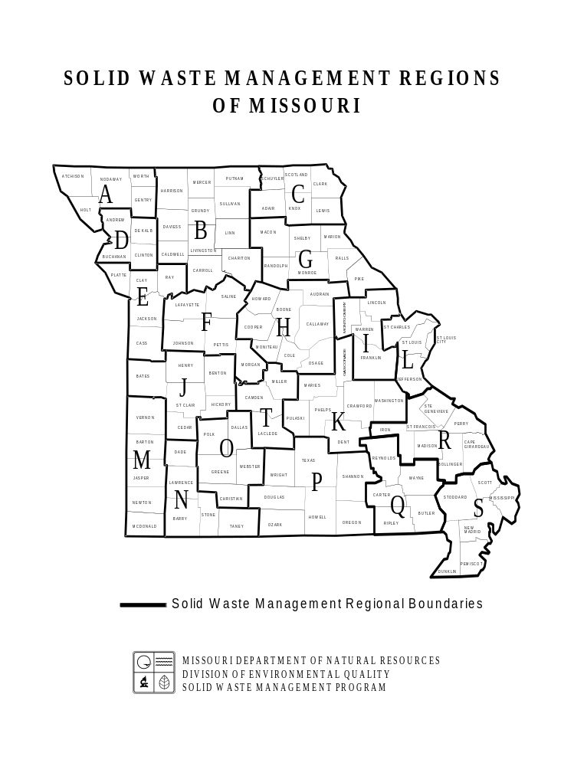
REGION A - Northwest Missouri SWMD
Northwest MO Regional Council of Governments
114 W. Third
Maryville, MO 64468
660-582-5121 FAX 660-582-7264
https://nwmorcog.org/programs/solid-waste/

REGION B - North Missouri SWMD
North Missouri SWMD
1104 Main Street
Trenton, MO 64683
660-359-5636 FAX 660-359-3096
http://www.ghrpc.org/Programs/solidwaste.htm

REGION C - Northeast Missouri SWMD
Northeast MO Regional Planning Commission
121 South Cecil St.
Memphis, MO 63555
660-465-7281 FAX 660-465-7163 http://www.nemorpc.org/solid-waste-management-district/

REGION D - Region D Recycling & Waste Mgt. Dist.
P.O. Box 139, 114 Main
Clarksdale, MO 64430
816-393-5250 FAX 816-393-5269 http://www.regiondrecycling.com/

REGION E - Mid-America Reg. Council SWMD
Mid-America Regional Council SWMD
600 Broadway, Suite 200
Kansas City, MO 64105
816-474-4240 FAX 816-421-7758 http://www.marc.org/Environment/SolidWaste/

REGION F – West Central Missouri SWMD
DSM, LLC 27 Point Hickory Court Lake Ozark, MO 65049
314-420-3058 FAX 660-463-7944 http://www.moswmd-f.com/

REGION G - Mark Twain SWMD Mark Twain Regional Council of Governments
42494 Delaware Lane
Perry, MO 63462
573-565-2203 FAX 573-565-2205 https://www.marktwaincog.com/mark-twain-solid-waste-management-district

REGION H - Mid-Missouri SWMD
Mid-Missouri SWMD
P.O Box 6015
Columbia, MO 65205
573817-6422 FAX 573-874-7132 http://www.mmswmd.org/

REGION I - East Central SWMD
Boonslick Regional Planning Commission
111 Steinhagen. PO Box 429 Warrenton, MO 63383
636-456-3473 FAX 636-456-2329 http://boonslick.org/east-central-missouri-solid-waste-management-district/

REGION J - Quad-Lakes SWMD
Kaysinger Basin Regional Planning Commission
221 North Second Street
Clinton MO, 64735
660-885-3393 FAX 660-885-4166 http://www.kaysinger.com/quad_lakes.php

REGION K - Ozark Rivers SWMD
Meramec Regional Planning Commission
#4 Industrial Drive
St. James, MO 65559
573-265-2993 FAX 573-265-3550 http://ozarkrivers.org/

REGION L - St. Louis-Jefferson SWMD
St. Louis-Jefferson SWMD
7525 Sussex Avenue
St. Louis, MO 63143
314-645-6753 FAX 314-645-6504 http://www.swmd.net/

REGION M – SWMD
407 S Pennsylvania Ave., Suite 203
Joplin, MO 64801
417-625-6626
FAX 417-625-6656
https://www.regionm.org/

REGION N - Southwest Missouri SWMD
P.O. Box 27, 205 15th St.
Monett, MO 65708
417-236-9012 Fax 417-236-9012 http://www.stoneco-mo.us/recycling/

REGION O – Ozark Headwaters Recycling and Materials Management District
Ozark Headwaters Recycling and Materials Mgmt. District
940 N. Boonville Ave, Room 303B Springfield, MO 65802
417-868-4197 FAX 417-868-4197 https://www.recycle417.com/

REGION P - South Central SWMD
South Central SWMD
P.O. Box 100
Pomona, MO 65789
417-256-4226 Fax: 417- 256-6188 https://www.scocog.org/solid-waste.html

REGION Q - Ozark Foothills Regional SWMD
Ozark Foothills Regional Planning Commission
3019 Fair Street
Poplar Bluff, MO 63901
573-785-6402 FAX 573-686-5467
http://www.ofrpc.org/rpcDetail.php?Ozark-Foothills-Solid-Waste-Management-District-3=

REGION R – Southeast Missouri SWMD
Southeast MO Regional Planning Commission
P.O. Box 366, 1 West St. Joseph St.
Perryville, MO 63775
573-547-8357 FAX 573-547-7283
http://semorpc.org/solid_waste_planning.html

REGION S – Bootheel SWMD
Bootheel Regional Planning Commission
105 E. North Main
Dexter, MO 63841
573-614-5178 FAX 573-614-5182
https://bootrpc.com/back-bootheel-solid-waste-management-district

REGION T - Lake of the Ozarks SWMD
33924 Olathe Dr.
Lebanon , MO 65536
417-426-5001 FAX 417-426-5010
http://www.ozarksgoinggreen.com/

12/01/21

